THE PRESIDENT’S OFFICE
REGIONAL ADMINISTRATION AND LOCAL GOVERNMENT
FORM FOUR JOINT EXAMINATION FOR GOVERNMENT SCHOOLS –JEGOS
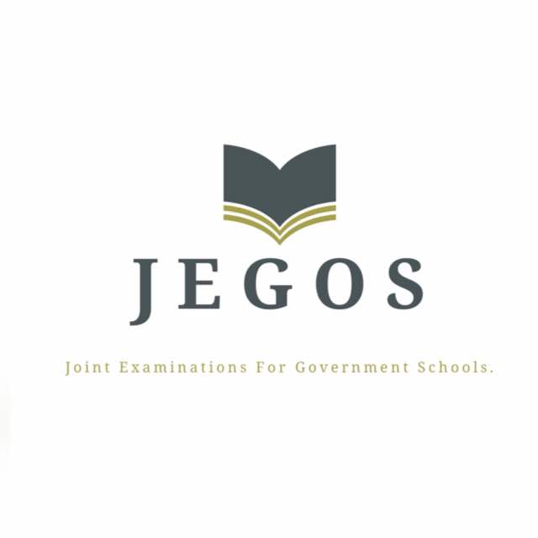

PRE-MOCK EXAMINATION
COMMERCE
MARKING SCHEME 2024

- Multiple choice questions; (1 mark@ for 10 items = 10 marks)
A | C | A | A | C | B | A | C | C | C

- Matching items; (1 mark@ for 6 items = 6 marks)
C | I | F | A | B | E

Section B (54 marks)
- (a) Importance of monetary policy;
- To control inflation
- To control deflation
- To stimulate the economy for faster growth.
- To increase employment opportunities
- To reduce the income inequality
- To stimulate mass production
- To influence allocation of resources
- To increase the level of investment
- To increase government income
- To reduce rural urban migration (1 mark@ times 5= 5 marks)

(b) Means of payment offered by commercial bank:
- Cheque
- Standing order
- Bank draft
- Credit transfer
- Credit cards
- Debit cards
- Direct debit
- Postal order
- E-banking
- Bills of exchange
- Promissory notes.
(1 mark@ times 4= 4 marks)

- (A) - Advantages of self-employment;
- Independence
- Financial rewards
- Income to the family
- Create job security
- High self-esteem/job satisfaction
- Financial freedom
- Direct attention to your customers

- Disadvantages of self-employment;
- Risk of failure
- Wrong decision
- Too much pressure
- Unstable income
- Loss of personal life
- Setbacks may affect your confidence and profits
- Some Tasks may be unpleasant
- Lack of employment benefits

(B) Disadvantages of refusing credit to the customers;
- Deteriorated social understanding with his customers
- Limited sales
- Limited profit
- Increased storage costs
- Limited business expansion
- Loss of additional income due to interest on credit
(1 mark@ for 9 points= 9 marks

- (a) Market research problems;
- It is expensive
- Lack of sufficient funds
- Language barriers
- Poor transport and communication network
- Inappropriate methodology
- Inexperience in interpreting research data
- Lack of enough personnel
(1 mark@ times 5= 5 marks)

(b) Possible Solutions;
- Development of infrastructure
- Establishment of training institutes to increase research expertise
- More funds should be made available
- The use of technology to overcome language barriers
(1 mark@ times 4= 4 marks)

- Advantages of standard gauge railway over road from Morogoro to Dar;
- Larger carrying capacity
- Less effect of weather
- Safer than road
- Cheaper than road
- Well organized than road
- Electric trains are faster than lorries
(1.5 marks@ times 6= 9 marks)

- Disadvantages of free trade;
- Collapse of domestic infant industries
- Production and consumption of harmful products
- Encourages dumping
- Danger of imported inflation
- Higher risks of unemployment
- Loss of government revenue
- Exhaustion of natural resources
(1.5 marks@ times 6= 9 marks)

- Differences in the premium amounts insured are required to pay;
- Age differences
- Occupational differences
- Financial differences
- Differences in places of residents
- Differences in their health status
- Differences in the length of their policies
(1.5 marks@ times 6= 9 marks)

- Demand is a dependent variable because it cannot determine its size; the size of demand is determined by the following factors;
- Commodity’s own price
- Consumer’s income
- Consumer’s taste and preferences
- Price of related commodity
- Population size
- Level of advertisement
- Economic condition
- Weather condition
Introduction = 2 marks; Main body = 2 @ point for six items = 12; Conclusion = 1 mark Total = 15marks

- – Advantages of government ownership;
- Defense requirements
- Basic industries
- Public utilities
- Infrastructure
- Prevention of monopoly (concentration of economic power);
- Curbing wasteful competition
- Development of backwards regions
- Financing the economy
- Provision of employment opportunities

- Disadvantages of government ownership;
- Limited skills
- Expensive to finance
- Low initiative
- Mis-handling of funds
- Uneconomical
- Discourages private investments
- Bureaucracy leads to delays
- Political influence
- Monopoly status.
Introduction = 2 marks; Main body = 2 @ point for six items = 12; Conclusion = 1 mark
Total = 15marks
- Advantages of indirect taxes;
- They are easy to collect
- They are not easy to evade
- Their burden is not easily felt
- They can stop consumption of harmful products
- It is not discriminative
- It protects home industries
- Guide the allocation of resources
- They help to stabilize the economy
- Wider tax base than direct tax
- Disadvantages of indirect taxes;
- It is regressive in nature
- It is inflationary in nature
- It creates inconvenience
- It is uneconomical
- May be biased
- Discourage demand
Introduction = 2 marks; Main body = 2 @ point for six items = 12; Conclusion = 1 mark
Total = 15marks

